End-to-end customer support through Agent Network
Business model innovation whereby companies provide comprehensive support to customers through a grassroots agent network

Large productive appliances running on renewable energy sources require regular and intensive maintenance and customer service. This challenge is compounded in rural areas as communities lack an adequate ecosystem of service providers who can facilitate access to these additional services. Scale up and adoption of productive leads hence needs operators to builda strong cost-effective infrastructure for last-mile customer support, servicing, and customer education. A robust last-mile service and distribution network is also important to develop trust with the customer and ensure there is constant feedback loop for the products and services provided.
Companies working in the last mile often end up providing the last mile services as a part of their product offering, which unfortunately adds to their costs and stressing their margins and growth prospects over time. This approach also limits the self-resilience of communities making them dependent on operators, amplifying the issue further. Additionally, providers and distributors facingmarket awareness and education challenges while doing business in rural remote areas often lose existing customers or fail to get strong market penetration as these communities typically rely on trust-based word of mouth messaging.
Research into successful companies shows that models that reach low-income consumers in remote areas need to consider innovative, cost-effective, and local context-based solutions. Resham Sutra has piloted an innovative method to tackle this issue of last-mile disconnect - via the creation of a last-mile agent network and last mile experience centers. This model essentially operates with the company identifying individuals from within the community to serve their communities directly as distribution and customer service agents. These agents have multiple roles and functions and are then trained to be the eyes and ears of the company on the ground. An agent’s role can range from providing after-sales support and maintenance to marketing to collecting field feedback, and more. For the community, this is very acceptable as they see the company representative as an insider who they trust and who speaks the same languages that they can relate to.

Such agent models have been successful with distribution and servicing of other renewable energy products like solar lamps, cookstoves and home systems and Resham Sutra has shown that a similar model can also be a win-win in the context of productive appliances – if the right agent network engagement and support structure is provided by the operator.

How the BMI is being done by other companies

The Government of India has taken active steps for the welfare of the weaver community, including providing financial assistance under flagship schemes such as the National Handloom Development Programme (NHDP) and the Handloom Weavers Comprehensive Welfare Scheme (HWCWS). The initiatives of the Government have ranged from strengthening access to finance, infrastructure and even market demand. While these initiatives have been encouraging, a large percentage of weaver households continue to earn less than 5000 rupees ($90) per month, living below or close to the poverty line. The low returns of their work have meant that the average number of weavers per household has decreased from 1.28 to 1.05 between the 2010 and 2020. Many organizations like SEWA Lucknow (http://www.sewalucknow.org/) have stepped in to innovate new technologies for these weaver communities to increase their output but there still exists an enormous gap in the provision of the last mile distribution of after sales support and services. Energy access has a huge role to play for upgrading this industry and with latest technical development in power looms and low wattage lighting, there is an opportunity to create successful last mile businesses and generate value if the issues of distribution and customer service can be solved in a cost effective way.

Agent networks have been successful in India due to their cultural sensitivity and geographical proximity to the communities and many organizationslike Sakhi Retail, Frontier Markets, Jaipur Rugs and Dharma life have utilized a last-mile agent network model to connect low income consumers with products and services. These companies have identified the need to help communities where end consumers establish resiliency by creating support systems for servicing and training that are localised and culturally well adapted. A central part of the success of this model is the identification and management of these agent network through local partnerships with trusted organisations such as NGOs. Furthermore, some of these companies are also using such a model to create changemakers in rural areas tackling issues on the awareness, accessibility, availability and affordability side.

Resham Sutra Private Limited - Empowering women by revolutionizing livelihoods and productivity through an ‘Agent Network’
Resham Sutra is promoting livelihoods in the wild silk industry (Tassar, Muga, and Mulberry) in rural India by providing end-to-end support for women weavers.

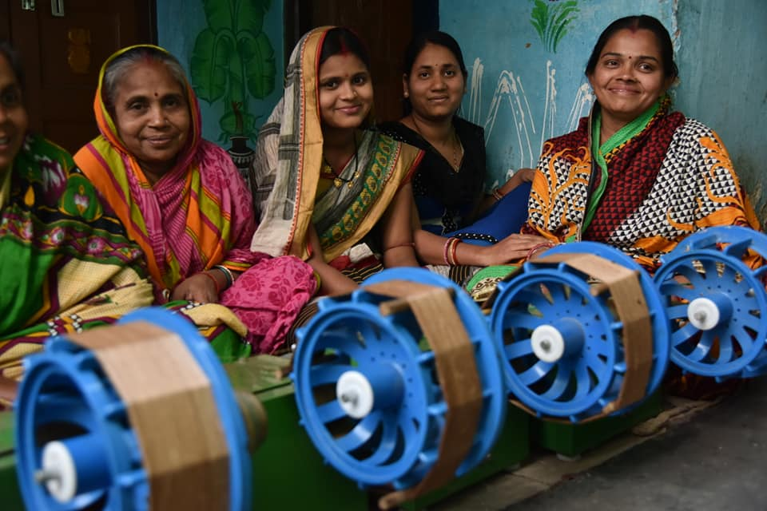
(photo courtesy: Resham Sutra Website)

Overview of organisation (1,700-2,000 characters)
Resham Sutra has set up community-level ‘Agent Networks’ that support the financing, servicing, distribution, and usage of innovative solar-driven technological products for women ‘silk’ entrepreneurs that they work with. The Agent Networks facilitate an end-to-end support system that provides not just access to finance and hence technology to the women weavers, but also access to business and technical support services. In doing so, the BMI promotes a ‘farm to fabric’ ecosystem, which supports these silk weavers to become more productive, efficient, and ultimately positively impact their lives. | Resham Sutra at a Glance  - Resham Sutra has pioneered innovation for rural textile producers. They manufacture innovative solar driven weaving machines, train and build capacity through their ‘Agent Networks’ of local entrepreneurs, thus providing a comprehensive ecosystem from 'farm to fabric' for women silk weavers.  - Key geographies / country of operation: Currently working in the Eastern and North Eastern States of India mostly. These include Assam, Jharkhand, Bihar, Orissa and Chhattisgarh.  - The financial market potential in India of the sector is $1.3 billion  - Year of foundation: 2016  - 22 staff members  - Annual turnover of $606,000 (2019)  - 11,000 silk reeling machines installed (2019)  - 11,000 Silk Workers (2019), Impacted more than 40,000 people and trained more than 18,000 women.  Business Model Innovation  - Name of product or service: Unnati Silk Reeling Machine supported with an agent network of service providers  - Name of the theme and innovative quality: Resilience, Last-mile support through a grassroots agent network.  - No. of SDG addressed: 1, 5, 7, 8, 9  Contact details  - Website: www.reshamsutra.com  - Name of contact person: Kunal Vaid

Quotes of founders / key customers / key supports on innovation and / or vision of organisation
<Technical requirements of products like ours and remote locations of customers necessitate innovations in last mile service delivery models. This model is now a pillar of strength for our company>
Business Model Innovations of organisation (4,000 characters)
The handloom industry is the second-largest employment generator in India, just after agriculture. There are an estimated 2.67 million weavers in India, of which 0.44 million are involved in silk production (Tassar, Muga, and Mulberry). 78% of these weavers are located in remote rural areas and about 70% of the total manpower engaged is women (Handloom census 2019-20), often disconnected from conventional markets. This isolates them from support services, financing mechanisms, and technology to improve their productivity and growth. Often also the products and/or services available are not of good quality and are not adapted to the needs of the communities and lack a cohesive after-sales support ecosystem. One of the ways organizations have been overcoming this barrier is through the creation of last-mile agent networks – investing into developing capabilities in the last mile for long term operational cost and competitive advantage.
Resham Sutra has been supporting silk weavers in rural India since 2016 through their modern solar-powered machines, training and agent-based distribution and after sales service model. They have developed a suite of compact and reliable solar powered spinning (Unnati and Silky Spin), reeling (Buniyaad and Sonalika), and weaving machines (Sun Kargha) for silk yarn and fabric production in collaboration with India’s Central Silk Board providing a more comprehensive approach and end-to-end ecosystem for silk.
Resham Sutra realized early in their business journey that in order to be successful while creating sustainable an impact and building resiliency in the community - the product needed to be a part of a larger ecosystem of support services. They observed that many end users questions, complaints, and repairs of the equipment could be solved at the source itself with some training and standardized protocols. They further realized that the enthusiasm of women to use the technologies needs to be curated regularly with on-ground education and capacity building and local trust was essential to ensure that gender issues don’t prevent the accurate and consistent flow of feedback and suggestions.
The company saw this as an opportunity to create a more grassroots-driven agent network where trained local members provided servicing, regular maintenance, and other after-sales support. A secondary benefit of the model also see was that the income-earning opportunities for the community members further improved their quality of life and increased their willingness to engage with the company. Over time, the community agents have become the eyes and ears on the ground for Resham Sutra and help the company manage high quality control at the last mile reducing defects and issues further downstream in the value chain. Percolationof information has become easier from and within the community allowing the company to continuously iterate and develop innovations from the bottom up.
The agent network process starts by identifying groups of people from the community who want to be part of this initiative. Resham Sutra does this in two ways: 1) By advertising amongst their customers who help in spreading the word and giving recommendations. 2) Soliciting recommendations from existing agents and partner NGO’s, who have connections in the particular community.
The typical profile of an agent is young men or women who have graduated from high school and have prior experience working with yarn or fabric (the majority so far belong to a weaver family, with their mother or sister being a producer). Once the agents are identified, they are provided a stipend to train for 3 weeks. The training modules are divided into technical trouble shooting, customer service, sales and marketing, and soft skills and Resham Sutra tailors the program based on the background and the cultural sensitivities of the participants. On graduating the agents go back to their communities and engage regularly with the women weavers, visiting them at their homes to provide them the support services while also updating them on company data, available government schemes and other relevant information. The agents are also always accessible to the women via a phone call. Till date the company has created a network of over 45 agent networks spread across more than 15 villages in Jharkhand and Chhattisgarh.
Leveraging the success of the Agent Networks, Resham Sutra has also started an experiment with a Rural Experience Center. These centers located in different villages, act as hubs where users can come and get a first-hand experience of using the different machines and access services and training. Resham Sutra is using the experience centers to scale the agent network by shifting the roles of the agents to trainers who further disseminate the training to the newly identified agents. The organisation is also bringing in more women into the agent network by partnering with NGOs who work with women.

Spotlight on Beneficiaries (1,000 characters)
Resham Sutra is empowering rural women through opportunities of self-employment in reeling, spinning & weaving in the Easten & North-Eastern states of India, mainly Assam, Jharkhand, Bihar, Odisha, and Chhattisgarh. Assam as a state alone compromises of nearly 33% of the entire weaver population of India. Nearly 55% of weaver families live under the poverty line. Many of these workers also face hunger and other work-related health impacts such as anaemia, fading eyesight, and other skin and bone problems. As healthcare is not readily available or affordable, weaver families are heavily indebted. Further, around 62% of weavers are semi-literate or illiterate and the school dropout rate among girls in these families is high at 20%.

Quotes from customers: <get one targeted towards the agent network>
Previously I had a lot of back pain from sitting on the floor thigh reeling. I had cuts to my hands and the skin on my thigh, my right leg was sore from the wooden spindle resting on it and my arm hurt from turning it. I feel so much better now I am able to use the Buniyaad [reeling machine]." - Gitanjeli Das, silk weaver, Fakirpur, Odisha.
Quotes from agents: < quote on the benefit of being in a network and Resham Sutra training >

Visualization of Business Model Innovation
End-to-end ‘Farm to Fabric’ ecosystem

Resham Sutra

Market Info
Experience products and services
Procure finished products and link to market
Sale of machines and raw materials
Rural experience centers – hubs providing end-to-end support for silk production
Capacity building training by Resham Sutra
Recruit agents through end-user and partners
Queries and feedback from customers
Provide Market awareness and Support services
Agent Network
Rural Women Weavers (end users)
Page 5
Spotlight on Partnerships (1,000 characters)
Resham Sutra sees partnerships as the key to reach the targeted consumers who typically belong to the bottom of the pyramid segment. For on-ground outreach support, they have tied up with NGOs and social enterprises such as Astitva Mahila Samiti. For funding or linkages with the banks, they have partnered with SELCO Foundation. The trust that these organizations have built on the ground is crucial for Resham Sutra to spread awareness for the adoption of these machines as well as conducting training events. They believe that technological innovations coupled with end-to-end support reach their true potential and make a lasting impact on the lives of people. Description of one partnership (bilateral or multilateral) that helped the organisation to develop innovations, to scale or achieve financial viability. Might be at one point of the value chain or along the value chain, with private or public partners.
<Partner Profile>

Replication and Scalability (1,000 characters)
Resham Sutra sees the agent network playing a role beyond just being service agents. Along with the Rural Experience Centres, they plan to expand the role of the agents into raw material procurement, marketing of end products, sales, and holistic capacity building. The company sees the agents as critical players for creating community resilience while ensuring mode localized sustainability.
Resham Sutra is exploring a scale up to the model is by expanding the role of their agents to becoming trainers and adopting the ‘train a trainer’ approach. The agents are incentivised to find potential new agents who can be a part of the network and to train them with the skills needed to play this role. This expanded network of agents is helpingResham Sutra expand its customer base to new geographies.
The company also believes that for sustained growth and replication of the business model, enabling government subsidies and financial access schemes such as the MUDRA loan, National Handloom Development Program, Handloom Weavers Comprehensive Welfare Scheme will play a big role as they will encourage entrepreneurs and agents to join the sector. The company is also a strong advocate of scaling through partnerships as there are several opportunities ranging from procuring the machines for the women to obtaining the raw materials to creating a market for the finished product that can be effectively done through strong partnerships.
Impact (1,000 characters)
Community: Resham Sutra has impacted more than 11,000 silk workers till date. Through their network, the women have increased their productivity levels as they are better equipped to handle challenges associated with using the solar powered machines. The level of income of the weavers on average has doubled from $40 per month to $80 per month and this increased income has led to the women investing more time and money in their children’s education, healthcare and quality of life.Also as the women are now seen as economic contributors, they have been empowered to have a decision making say in their households and communities and have developed leadership and organizational skills.
Organisation: The organization has grown to 22 people in the headquarters and about 45 agents networks on the ground. This network has enabled the Resham Sutra to penetrate hard to reach areas and scale their operations. More so, with this network they are able to cut back on the financial expenses made to make regular field visits
Environment:Through its solar powered machines, Resham Sutra has been able to run power looms that would typically use diesel generators on a renewable energy source.
Acknowledgements (500 characters)
Interview:
Kunal Vaid

Fourth All India Handloom Census, link here
https://ashden.org/winners/resham-sutra/
According to the handloom census of 2019-20
Fourth All India Handloom Census, link here
The Centre for Handloom Information and Policy Advocacy
https://ashden.org/winners/resham-sutra/

